2018 Applied Maths Higher Level Questions

1.
(a)
A parcel rests on the horizontal floor of a van.
The van is travelling on a level road at 14 m s^{–1}.
It is brought to rest by a uniform application of the brakes.
The coefficient of friction between the parcel and the floor is $\frac{2}{5}$.
Show that the parcel is on the point of sliding forward on the floor of the van if the stopping distance is 25m.

(b)
A car C moves with uniform acceleration a from rest to a maximum speed u.
It then travels at uniform speed u.
Just as car C starts, it is overtaken by a car D moving in the same direction with constant speed $\frac{3u}{4}$.
Car C catches up with car D when car C has travelled a distance d.
- Show that, at the instant car C catches up with car D, car C has been travelling with speed u for a time $\frac{4d}{3u}-\frac{u}{a}$.
- Find d in terms of u and a.

2.
(a)
An aircraft travels at a speed of 400 km h^{–1} in still air. The aircraft sets out to fly from P to Q where Q is north of P.
- In what direction should the pilot set his course if there is a wind of 60 km h^{–1} blowing from the north-east?
- How far is the aircraft from P after 20 minutes?

(b)
A river flows with constant speed 4 m s^{–1} between straight parallel banks a distance
60 m apart. A woman can row a boat with speed 1 m s^{–1} in still water.
- How long will it take the woman to cross from bank to bank going across in the shortest time?
- Find the distance travelled by the boat when it crosses by the shortest path.
(i.e. to the nearest reachable point downriver on the opposite bank.)

3.
(a)
A particle is projected from a point P with speed 60 m s^{–1} at an angle of 30° to the horizontal. At the same time a second particle is projected from a point Q with speed 50 m s^{–1} at an angle β to the horizontal.
P and Q are on the same horizontal level and are 100 m apart.
The particles collide at R as shown in the diagram.
- Show that sin β = $\frac{3}{5}$.
- Find the distance |PR|.

(b)
A plane is inclined at an angle of 30° to the horizontal.
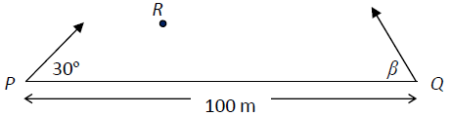
A particle is projected up the plane with initial speed u m s^{–1} at an angle θ to the inclined plane.
A second particle is projected up the plane from the same point and with the same initial speed u m s^{–1} but at an angle α to the inclined plane (where α ≠ θ).
The two particles hit the same point on the inclined plane.
The plane of projection is vertical and contains the line of greatest slope.
- Find the time of flight for each particle and show that the ratio of the times of flight for the two particles is $\frac{\sin{θ}}{\sin{α}}$.
- Find, in terms of u, the range when θ = 45° and hence or otherwise show that α = 15°.

4.
(a)
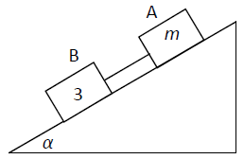
A block A of mass m is connected by a light inextensible string to a second block B of mass 3 kg.
They slide down a rough inclined plane which makes an angle α with the horizontal where tan α = $\frac{3}{4}$.
The string remains taut in the subsequent motion.
The coefficient of friction between A and the plane is $\frac{3}{4}$.
The coefficient of friction between B and the plane is $\frac{1}{3}$.
The system is released from rest.

- Find the acceleration of B, in terms of m
- Find the value of m if the tension in the string is 3·92 N.

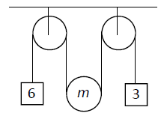
(b)
A moveable pulley of mass m is suspended on a light inextensible string between two fixed pulleys as shown in the diagram.
Masses of 6 kg and 3 kg are attached to the ends of the string.
The system is released from rest.
- Show, on separate diagrams, the forces acting on the moveable pulley and on each of the masses.
- Find in terms of m the tension in the string.
- For what value of m will the acceleration of the moveable pulley be zero?

5.
(a)
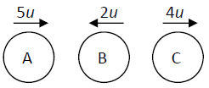
Three identical small smooth spheres A, B and C, each of mass m, lie in a straight line on a smooth horizontal surface with B between A and C.
Spheres A and B are projected towards each other with speeds 5u and 2u respectively, and at the same time C is projected along the line from B away from B with speed 4u.
The coefficient of restitution between each pair of spheres is e.
After the collision between A and B there is a collision between B and C.
- Find, in terms of e and u, the speed of each sphere after the first collision.
- Show e > $\frac{5}{7}$.
- If e = $\frac{6}{7}$ show that B will not collide with A again.

(b)
A small smooth sphere P, of mass 2m, moving with speed 4u, collides obliquely with an equal smooth sphere Q, of mass 3m, moving with speed u.
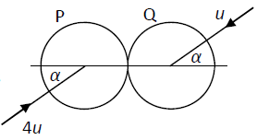
Before the collision the spheres are moving in opposite directions, each making an angle α to the line of centres, as shown in the diagram.
The coefficient of restitution between the spheres is $\frac{1}{5}$.
- Find, in terms of u and α, the speed of each sphere after the collision.
- After the collision the speed of P is twice the speed of Q.
Find the value of α.

6.
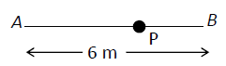
(a)
Two points A and B are 6 m apart on a smooth horizontal surface. A particle P of mass 0·5 kg is attached to one end of a light elastic string, of natural length 2·5 m and elastic constant 8 N m^{–1}. The other end of the string is attached to A.
A second light elastic string, of natural length 1·5 m and elastic constant 12 N m^{–1} has one end attached to P and the other end attached to B, as shown in the diagram.
Initially P rests in equilibrium at the point O, where AOB is a straight line.
- Find the length of AO.
- The particle P is now displaced in the direction AB, through such a distance that neither string goes slack, and is then released.
Show that P moves with simple harmonic motion about O.

(b)
A particle P is attached to one end of a light inextensible string of length d. The other end of the string is attached to a fixed point. The particle is hanging freely at rest, with the string vertical, when it is projected horizontally with speed u.
The particle moves in a complete vertical circle.
- Show that u ≥ $\sqrt{5gd}$.
- As P moves in the circle the least tension in the string is T₁and the greatest tension is kT₁.
Given that u =$\sqrt{6gd}$, find the value of k.

7.
(a)
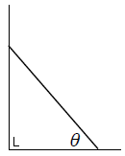
One end of a uniform ladder, of weight W and length l, rests against a rough vertical wall, and the other end rests on a rough horizontal floor.
The coefficient of friction between the ladder and the wall is $\frac{\sqrt{3}}{2}$ and the coefficient of friction between the ladder and the floor is $\frac{2}{5\sqrt{3}}$.
The ladder makes an angle θ with the floor and is in a vertical plane which is perpendicular to the wall.
The ladder is on the point of slipping.
Find the value of θ.

(b)
Two equal uniform rods, AB and BC, smoothly jointed at
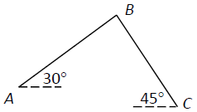
B, are in equilibrium with the end C resting on a rough horizontal plane and the end A freely pivoted at a point above the plane.
30° and 45° are the inclinations of AB and BC to the horizontal as shown in the diagram.
The coefficient of friction between BC and the plane is μ.
Show that μ ≥ $\frac{9-\sqrt{3}}{13}$.

8.
(a)
Prove that the moment of inertia of a uniform circular disc, of mass m and radius r, about an axis through its centre perpendicular to its plane is ½ mr²

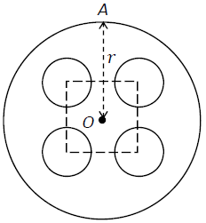
(b)
A wheel consists of a uniform circular disc of radius r with four circular holes each of radius $\frac{r}{4}$.
The centres of the holes form a square and each centre is $\frac{r}{2}$ from the centre of the disc O.
A is a point on the circumference of the wheel which is equidistant from the centres of two holes.
- If m is the mass of the wheel after the holes have been punched in it show that $\frac{m}{12}$ is the mass of the material removed to create each hole.
- Find the moment of inertia of the wheel about an axis through O perpendicular to the plane of the wheel.
- The wheel can turn freely in a vertical plane about an axis through A perpendicular to the plane of the wheel. Given that the period of small oscillations of the wheel is $k\sqrt{r}$, find the value of k correct to 2 decimal places.

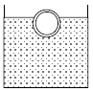
9.
(a)
A buoy in the form of a hollow spherical shell of external radius 0·7 m and internal radius 0·65 m floats in water.
The density of the material of the shell is 3430 kg m^{–3}.
What percentage of the volume of the buoy is immersed?
[Density of water = 1000 kg m^{–3}]

(b)
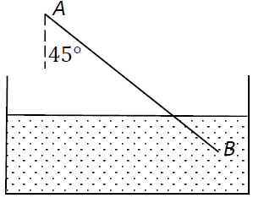
A thin uniform rod AB of length 2h and weight W, can turn feely about the end A, which is fixed at a height h above the surface of water into which the other end dips.
The rod is in equilibrium when inclined at 45° to the vertical.
Find the relative density of the rod.

10.
(a)
If $\frac{dy}{dx}$= 3 sin 3x + cos 5x and y = 1 when x =, find the value of y when x = .
Give your answer correct to 2 decimal places.

(b)
If there were no emigration, the population x of a certain county would increase at a constant rate of 2·5% per annum. By emigration the county loses population at a constant rate of n people per annum.
When the time is measured in years then $\frac{dx}{dt}=\frac{x}{40}-n$
- If initially the population is P people, find in terms of n, P and t, the population after t years.
- Given that n = 800 and P = 30 000, find the value of t when the population is 29 734.

